Supplementary Material: Methods
Contents
Methods 1
Characterizing Spatial Patterns 1
Agricultural Conservation Planning Framework (ACPF) 1
Private planning goals 7
Quantifying outcomes from the planning framework 8
Environmental outcomes 8
Opportunity Costs 8
Discount Cash Flow (DCF) Analysis 9
Structural feasibility 11
System Implementation Costs 12
Enterprise Budgets 12
Results 29
HUC12 Watershed Outcomes 29
Bioeconomic outcomes 31
Transportation Costs 31
Bioeconomy System Evaluation 34

Methods

Characterizing Spatial Patterns

Agricultural Conservation Planning Framework (ACPF)

Planning Framework
The Agricultural Conservation Planning Framework (ACPF) is first and foremost a planning concept that identifies healthy soils as being the foundation for productive landscapes, while also improving water quality and soil quality and structure. The ACPF was developed as the USDA/ARS National Laboratory for Agriculture and the Environment (NLAE) in Ames, IA as resource for land managers to create watershed implementation plans based on watershed characteristics, including hydrology, slopes, soils, and land cover. The ACPF was used in this study because it can facilitate a spatially explicit approach by using the GIS toolbox that was developed in parallel to the planning framework. The ACPF principles can be spatially targeted at field and sub-field scales, thus providing ample opportunities for improving in-field soil management, intercepting surface and subsurface runoff, along with stabilizing streambanks. More information on the foundational principles and application of ACPF are available in Tomer et al. (2013, 2015a, 2015b) and on the ACPF Hub website (acpf4watersheds.org).

GIS Toolbox
The GIS toolboxes was developed to characterize agricultural landscapes and site conservation practice opportunities at the HUC12 watershed-scale that complement agricultural systems and target portions of agricultural land for conservation practices. Therefore, it is a useful tool for building and demonstrating a spatial framework for multifunctional agricultural landscape transformation centered on producing grassy feedstocks for renewable natural gas (RNG) production at a local anaerobic digestion (AD) facility. The portions of the field targeted are assumed to be degraded based on slope and hydrology characteristics, cropping history, and soil types.
The GIS toolbox uses a core dataset organized by HUC12 watershed, however, for this project the core datasets and outputs were aggregated to the 32 km supplyshed centered around the anaerobic digestion (AD) facility. The following ACPF GIS tools were the foundation for developing a spatial framework for multifunctional agricultural landscapes that prioritizes ecological uplift and agronomic outcomes. More information on the GIS toolset and input/output datasets is available in Porter et al. (2025).
- DEM Preparation
1.a. DEM: Pit Fill / Hole Punch (intermediate outputs)
A digital elevation model (DEM) was created by mosaicking 1-meter resolution county DEMs and clipped to a 1000-meter buffered boundary around the 47 HUC12 watersheds intersecting the 32 km supplyshed. The DEM was resampled to 2-meters and turned to centimeters for improved processing. The pit filling and hole punching tool modified the DEM to remove slight irregularities, such as pits and small depressions that are considered artifacts of the collection process.

1.d. Manual Cutter / Dam Builder (intermediate outputs)
The DEM was further modified to remove digital dams and route surface flow networks appropriately across the landscapes and in-channels. This step is essential to ensure accurate spatial targeting for vegetative conservation practices in the demonstrated biomass-based bioeconomy. There were 23,040 cutlines and 18 damlines drawn to hydrocondition the DEM and simulate overland flow patterns. The hydroconditioned DEM is generated by first filling all sinks to that of the pour point out of the depression, then applying the ArcGIS D8 flow routing algorithm (ESRI, 2011). The D8 flow routing algorithm looks at overland from each grid cell and directs flow paths to a single neighboring cell based on the estimated steepest downward slope gradient (i.e., largest elevation change).

- Develop Stream Network and Catchments
2.a. Flow Network Definition – Area Threshold (intermediate output)
The hydroconditioned DEM was then used to delineate surface flow paths that is later used to target runoff interception in strategic locations to improve water quality and reduce soil erosion.

2.c. Stream Reach and Catchments (bioeconomy output)
Segments of the surface flow paths are classified as either perennial streams or ephemeral flow networks. Catchment areas were delineated to each perennial stream network, while ephemeral flow networks are removed from this layer.

2.d. Merge Stream Reach with Water Bodies (intermediate input)
The LiDAR breaklines layer (https://geodata.iowa.gov/pages/lidar) was used to delineate wide rivers and large bodies of water in the dataset. Manual editing of the breakline layer was necessary to improve accuracy and include additional wide rivers and lakes that met the criteria defined in the ACPF User Manual (Porter et al. 2025).

- Field Characterization
3.a.1 By-field Slope Statistics (intermediate output)
Generated a slope raster for the study area and performed zonal statistics to generate a table summarizing descriptive statistics for slopes within each field boundary.

3.b. Tile Drainage Determination (intermediate output)
Estimate fields that are managed with tile drainage based on slope characteristics and soils information. The dominant soil characteristics used to estimate tile drainage locations was that greater than or equal to 40% of field consists of a dual drainage hydrologic group (A/D, B/D, or C/D) class soil.

3.c. Distance to Stream (intermediate output)
Generated a raster that models the horizonal distance to the perennial stream from each grid cell across all 47 HUC12 watersheds.

- Precision Conservation Practice Siting
4.f. Contour Buffer Strips (bioeconomy output)
The contour buffer strips tool was used to site locations for prairie strips in row cropped fields that could be harvested for biomass. The prairie strip width was assumed to be 18.3 meters to accommodate farm equipment harvesting the prairie biomass and provide some wildlife habitat opportunities.

- Impoundment Siting
5.a. Nutrient Removal Wetlands (bioeconomy output)
The nutrient removal wetlands siting tool was modified to maximize storage potential of the impoundment and the buffer height was adjusted to site locations suitable for 1.6-meter-high buffers. The nutrient removal wetland tool is requiring a lot of processing time, so the largest spacing distance (250 meters) was used to site opportunities to reduce processing time. In general, the ACPF toolbox has relatively quick processing times when used as intended—one HUC12 watershed at time—but in this study 47 HUC12 watersheds were being analyzed at a time so some decisions were made that might reduce siting opportunities in order to improve processing times.

- Riparian Assessment
6.a. Create Riparian Catchments (intermediate output)
Delineated catchments every 250 meters along the perennial stream corridor.

6.b. Create Riparian Attribute Polygons (intermediate output)
Generated a 15-meter by 250-meter polygon on either side of the perennial stream corridor. This data layer is used for visualizing stream side conditions within each riparian catchment, including slope, land use, soils and buffer design types.

6.c. Height Above Channel (intermediate output)
Summarized the elevation difference between each grid cell in the hydroconditioned DEM and perennial stream channel cells to estimate the extent of low-lying areas in the riparian corridor.

6.d. Riparian Function Assessment (bioeconomy output)
Classified each riparian buffer width and vegetation type, based on combinations of estimated runoff delivery and water table depth. Despite recommended buffer width being an output from the tool, it was assumed in this study that each buffer was 30.5 meters wide and approximately 5.0 meters from the stream would remain unharvested; leaving 25.5 meters of harvestable prairie biomass.

6.e. Denitrifying Practices (bioeconomy output)
Riparian areas are targeted for saturated buffers using practice standard criteria identified by the NRCS. Sites suitable for saturated buffers have greater than 1.7% soil organic matter and coarse material content less than 65%, in addition to poorly drained soil classifications. Similar to the riparian buffers, the buffer width is assumed to be 30.5 meters wide, with 25.5 meters of harvestable prairie biomass.

- Soil Vulnerability Index
7.a1. Mapunit SVI – Calculate SVI for All Components (intermediate output)
7.a2. Mapunit SVI – Summarize Mapunit SVI (intermediate output)
7.b1. By Pixel SVI – Get Soils Data for Dominant Component (intermediate output)
7.b2. By Pixel SVI – Generate By-Pixel SVI Rasters (intermediate output)
7.b3. By Pixel SVI – Summarize Field SVI (prioritization output)

Private planning goals
The case study AD facility stated that they will source 809 ha of cereal rye and 809 ha of prairie from the region. The AD facility will store feedstock material to digest with the cattle manure generated onsite. Ideally the feedstock supply will be close to the facility, however, in a developing biomass market, it is prudent to evaluate several supplysheds distances from the facility to assess bioeconomic viability and provide more field opportunities to pursue for growing and harvesting either prairie or cereal rye biomass (reference). The furthest supplyshed distance was 32 km and was successively reduced by 8 km (e.g., 8, 16, and 24 km).
Table S1. Synthesis of Prioritization Siting Criteria. Prioritization criteria used to select vegetative conservation practices opportunities sited by the ACPF GIS Toolbox. Criteria was based on estimated nitrate (NO₃) loads and intervention reduction potential, degraded hillslopes, habitat potential, and logistical considerations.
 | NO₃ | Sediment | Habitat | Logistical Design Considerations
Cereal Rye | Corn fields with average N fertilizer | SVI Classes: High & Moderately High | - | - No-till fields  - Corn-Soybean Rotation  - Continuous Corn
NRW | Intercept 45% of agricultural land  Receives tile drainage | - | - | Wetland & buffer centered on single field.
Riparian Saturated Buffers | Intercept tile drainage | - | 100’ buffer strip width | One (1) rod from edge of ditch/streambank will not be harvested to protect streambank.
Riparian Buffers | Intercept surface runoff. Saturated buffers will be more effective at treating tile drained fields, so tile drained fields were excluded from siting. |  | 100’ buffer strip width | One (1) from edge of ditch/streambank will not be harvested to protect streambank.
Perennial Cover | Corn fields with average N fertilizer for the area | High, moderately high & moderate SVI classes | - Prairie strips 60’ buffer width  - Landscape mosaic of patches (whole field conversion). Reported permanent easements in NCED was used to determine permanent prairie habitat. | In cases of prairie strips, only locations that occupied a minimum of 10% of a field was retained to capture multiple benefits (Schulte et al. 2017).

Quantifying outcomes from the planning framework

Environmental outcomes
OFE tool sediment loads
FiNRT nutrient loads, reduction fractions, MRTN,
Literature review for reduction fraction sources: CO2, N2O, Biomass yields, energy potential, habitat and connectivity.
Opportunity Costs
Iowa custom rate surveys (Massey 2020; Plastina et al. 2026), land rent data (Massey & Brown 2021; Plastina et al., 2022b; Bravard et al., 2022), and local information on cereal rye, prairie reconstruction, nutrient removal wetlands, saturated buffers, riparian buffers and prairie strips were used to determine per hectare enterprise budgets for practices integrated into row cropping systems (Table S9). It is important to note that enterprise budgeting, although widely used, does not account for all costs faced by farmers such as indirect or nuanced costs that come with changes in production. We considered three categories in the budget: 1) site preparation and establishment, 2) annual and periodic management cost, and 3) opportunity cost of land.
Site preparation and establishment often involves tillage and herbicide treatment to remove perennial weeds (Jarchow and Liebman 2010). Then seed must be drilled into the ground and, depending on the season, the soil packed down using a cultipacker to ensure seed to soil contact (Jarchow and Liebman 2010). We defined bioenergy grassland as a planted system based on a conservation-oriented prairie seed mix suitable for the region. Management involves mowing, baling, fertilizing and removing the biomass. To ensure good establishment, the new prairie should be mowed at least two to three times in the first year and once a year subsequently for biomass harvest (Jarchow and Liebman 2010). Opportunity costs were in the form of land rent as it is often used to represent forgone revenues from alternative cropland usage (Tyndall et al. 2013). Opportunity costs of land were calculated by using area-weighted land rent estimates for the counties in the GRB (Massey and Brown 2021; Plastina et al., 2022).

Discount Cash Flow (DCF) Analysis
Across a range of potential farmgate biomass prices, potential biomass yields and bioeconomic supplyshed distances, we calculated the annualized per hectare costs (Table S10) and net present value (NPV) of this biomass system using standard discounted cash flow techniques. We calculated profitability across 13 different prices: $22 dry Mg⁻¹, $33 dry Mg⁻¹, ... $154 dry Mg⁻¹ and five different real discount rates 5%, 6%, 7%, 8% and 9%. for both cereal rye and prairie biomass. There were four different biomass yields for cereal rye included in the analysis: 0.9 (Koehler-Cole et al. 2020, Crespo et al. 2024), 4.0 dry Mg ha⁻¹ (Krueger et al. 2011; Feyereisen et al. 2013; Malone et al. 2024), 7.0 dry Mg ha⁻¹ (Crespo et al. 2024), and 10.1 dry Mg ha⁻¹ (Huddell et al. 2024). The lower-bound of our cereal rye yield range was based on several in-field measurements and review papers reporting historical rye yields. Huddell et al. (2024) had the most comprehensive database and report on known winter rye studies along with fertilizer management decisions. There were four different biomass yields for prairie included in the analysis: 4.2 Mg ha⁻¹, 7.6 Mg ha⁻¹ (Tillman 2006; Nichols et al. 2014, Giddens et al. 2017), 11.0 Mg ha⁻¹, 14.4 Mg ha⁻¹ (Dietzel et al. 2015) Mg ha⁻¹. A base discount rate of 6% was selected because it represents a 10-year average real rate of return to assets on Iowa farms. To calculate annualized net present values, a capital recovery factor (Eq. #1) was used over the 10-year total net returns.

 | $$A=NPV\frac{r{\left(1+r\right)}^{t}}{{\left(1+r\right)}^{t}-1}$$ | (1)
where A is the equal annual income, NPV is net present value of production system, r is the discount rate, and t is time horizon (10 year).
We also used equation (1) to estimate the prices and yields at which cereal rye and prairie biomass production would breakeven in the study supplyshed given the direct costs of production and opportunity costs in the case of prairie, time horizon, and discount rates. Lastly, we estimated a total biomass yield for our baseline, each radial distance band used represented a distance scenario to evaluate the breakeven costs of the biomass system when transportation costs are considered. Then, the total potential revenue across 13 different prices: $22-$154 dry Mg⁻¹ and four different yields for cereal rye and prairie, assuming the annualized production costs as calculated above.

Structural feasibility
GeoProfit tool profitability
Yield Stability

System Implementation Costs

Enterprise Budgets

Prairie biomass (Patch + CBS)
Table S2. Costs associated with planting multi-purpose prairie buffer strips and whole-field reconstruction. Costs presented in 2026 USD. Adapted from Tyndall et al., 2013 and Bravard et al. 2022.
Cost Activities/Items | Year | Range of Costs |  | Mean cost | Unit | Notes | Reference
 |  | min | max
Prairie Biomass Bed Prep - Fall
Mowing | 0 | $23.47 | $51.89 | $38.18 | per hectare | Mowing will make it easier for the sod to be disked but won’t be as advantageous as the removal of the vegetation prior to disking. Prescribed fire or grazing could also be completed in lieu of mowing or haying. Hay - mowing / ha. | Plastina & Johanns 2026
AND/OR

Straw or corn stalk baling - large round or square bales without wrap | 0 | $98.84 | $197.68 | $143.32 | per hectare | Straw or corn stalk baling-large round or square bales without wrap / bale (rates are per bale). | Plastina & Johanns 2026
AND

Tillage - Disk/Chiseling | 0 | $74.13 | $252.04 | $170.50 | per hectare | Tillage needs vary from site to site. This captures a range of options. Cost could be zero if drilling into a bean field, and up to 6 times. Assumed 3 passes since it could be anywhere between 0 and 6 passes. Disk/chiseling / ha. | Plastina & Johanns 2026
Prairie Biomass Planting
Seed | 0 | $210.04 | $452.19 | $417.60 | per hectare | 2025 Iowa Pheasants Forever seed price per hectare for CP-43 mesic prairie pollinator mix (20/20). | 2025 Iowa Pheasants Forever
Planting - Broadcast | 0 | $19.77 | $61.78 | $38.67 | per hectare | Seeding grass, broadcast with tractor / ha. | Plastina & Johanns 2026
Land roll | 0 | $9.88 | $44.48 | $24.09 | per hectare | Perform this in the fall after seeding prairie. | Plastina & Johanns 2026
OR
Planting - Drill | 0 | $24.71 | $66.72 | $48.06 | per hectare | Drilling small grain / ha. | Plastina & Johanns 2026
Prairie Biomass Establishment - Year 1-3
Mowing | 1 | $88.96 | $370.65 | $200.52 | per hectare | Mow 3 x in year 1 during stand establishment phase. No baling. Mowing CRP or pasture / ha. | Plastina & Johanns 2026
Mowing / Conditioning | 2 | $24.71 | $61.78 | $42.75 | per hectare | Mow, rake, and bale materials at least once per year after year 1. This management is an alternative to periodic burning. Assumption is land manager would either mow and bale or burn. | Plastina & Johanns 2026
Raking | 1-2 | $18.53 | $37.07 | $24.46 | per hectare | Mow, rake, and bale materials at least once per year after year 1. This management is an alternative to periodic burning. Assumption is land manager would either mow and bale or burn. | Plastina & Johanns 2026
Herbicide & Application | 2 | $26.51 | $48.75 | $35.16 | per hectare | Roundup PowerMax 3 Bulk: $14.16 ha⁻¹; Spraying without incorporation using a tractor. | Herbicide Cost: Akron Services, Inc. 2025  Application Cost: Plastina & Johanns 2026
OPTIONAL

Burn - Spring | 3 | $49.42 | $148.26 | $82.41 | per hectare | Controlled burning of grass, CRP, pasture. Burning the grass is an alternative to mowing and baling. Assumption is land manager would either mow/bale or burn. Burn every 3-5 years after establishment. | Plastina & Johanns 2026
Prairie Biomass Crop Management
Fertilizer application | 3 | $231.59 | $339.42 | $281.75 | per hectare | 60#N, 35#P2O5, 160#K2O to replace nutrients harvested in biomass + application costs. Assume only half of prairie harvested because only 50% is harvested annually. Anhydrous injection with toolbar. P&K broadcasted and incorporated. | Iowa Production Cost Report (Bi-Weekly)  Agricultural Marketing Service, 4/3/2026
Mowing/Conditioning | 3-n | $24.71 | $61.78 | $42.75 | per hectare |  | Plastina & Johanns 2026
Raking | 3-n | $18.53 | $37.07 | $24.46 | per hectare |  | Plastina & Johanns 2026
Silage - chopping | 3-n | $58.81 | $100.82 | $77.29 | per hectare | Multiplied average cost by 7.6 Mg ha⁻¹. Assuming 7.6 Mg ha⁻¹ (fertilized; Nichols et al. 2014). | Cost: Plastina & Johanns, 2026  Harvest Method: Igos et al. 2016
Straw or corn stalk baling - large round or square bales without wrap | 3-n | $111.94 | $223.87 | $147.20 | per hectare | Assuming large hay bale (5x6) dry weight is 0.68 Mg (Edwards 2020), therefore there are 11.2 bales ha⁻¹ (7.6 / 0.68) and the cost of baling is $13.60 per bale. | Cost: Plastina & Johanns 2026  Harvest Method: Edwards 2020
Overall Management Impact
Land Rent | A | variable |  |  |  | GIS calculated area-weighted average rent based on CSR2 for land used by practice. | Bravard et al., 2022
Increased Crop Management | A | 4% |  | $56.68 |  | Increased Management cost is a general category; includes extra time spent: walking fields to assess cover crop progress, adjusting equipment, etc. Assumed to be 4% of establishment & Mgt cost. | Tyndall et. al, 2014

Cereal Rye
Table S3. Custom rate costs associated with winter cereal rye cover crop (Secale cereal) planted in Iowa; primary cover goal is nitrogen scavenging. Costs presented in 2026 USD. Cost activities adapted from Bravard et al. 2022.
Cost Activities¹ | Year | Range of Costs |  | Mean cost | Unit | Notes | Reference
 |  | min | max
Winter Rye Biomass Planting
Seed² | 0 | $0.62 | $0.99 | $85.79 | per hectare | 134.5 kg ha⁻¹ seeding rate.
Planting - Aerial | 0 | $24.71 | $44.48 | $36.32 | per hectare | Aerial seeding rate: 93-168 kg ha⁻¹ PLS. | Plastina & Johanns 2026
OR
Planting - Broadcast | 0 | $19.77 | $61.78 | $38.65 | per hectare | Broadcast seeding rate: 77-140 kg ha⁻¹ PLS. | Plastina & Johanns 2026
OR
Planting - Drill | 0 | $22.24 | $61.78 | $47.07 | per hectare |  | Plastina & Johanns 2026
Winter Rye Nutrient Management
N application - Fall (22 kg of total N ha⁻¹) | A | $40.40 | $72.28 | $63.90 | per hectare | liquid side dressing + other operations / hour; assumed that it takes 60 hours (bulk fertilizer/spreader); Fall application: 22-45 kg total N ha⁻¹. Anhydrous, injecting, with toolbar. | Nutrient Cost: Iowa Production Cost Report (Bi-Weekly)  Agricultural Marketing Service, 4/3/2026  Application Cost: Plastina & Johanns 2026
N application - Spring (90 kg of total N ha⁻¹) | A | $112.18 | $160.62 | $135.14 | per hectare | liquid side dressing + other operations / hour; assumed that it takes 60 hours (bulk fertilizer/spreader); Spring application: 90-112 kg of total N ha⁻¹. Anhydrous, injecting, with toolbar. | Nutrient Cost: Iowa Production Cost Report (Bi-Weekly)  Agricultural Marketing Service, 4/3/2026  Application Cost: Plastina & Johanns 2026
OR
N application - Spring (112 kg of total N per ha⁻¹) | A | $109.34 | $152.58 | $128.09 | per hectare | liquid side dressing + other operations / hour; assumed that it takes 60 hours (bulk fertilizer/spreader); Spring application: 112-134 kg of total N ha⁻¹). Anhydrous, injecting, with toolbar. | Nutrient Cost: Iowa Production Cost Report (Bi-Weekly)  Agricultural Marketing Service, 4/3/2026  Application Cost: Plastina & Johanns 2026
AND (if using N application)
P & K application - (28 kg of P ha⁻¹) |  | $69.14 | $101.66 | $85.50 | per hectare | P application - (28 kg of P ha⁻¹) & K application - (45-56 kg of K ha⁻¹). Broadcast, incorporated, tractor. | Nutrient Cost: Iowa Production Cost Report (Bi-Weekly)  Agricultural Marketing Service, 4/3/2026  Application Cost: Plastina & Johanns 2026
Winter Rye Biomass Harvest
Mowing/Conditioning | A | $24.71 | $61.78 | $42.75 | per hectare |  | Plastina & Johanns 2026
Raking | A | $18.53 | $37.07 | $24.46 | per hectare |  | Plastina & Johanns 2026
Silage - chopping | A | $19.72 | $33.80 | $25.92 | per hectare | Multiplied the average cost by 4.0 Mg ha⁻¹. Assuming 4.0 Mg ha⁻¹ (fertilized; Feyereisen et al. 2013; Malone et al. 2024). | Cost: Plastina & Johanns 2026  Harvest Methods: Igos et al. 2016; Sievers 2024.
Hay baling - large round or square bales without wrap | A | $37.56 | $75.12 | $49.39 | per hectare | Assuming large hay bale (5x6) dry weight is 0.68 Mg, therefore there are 5.88 bales ha⁻¹ (4.0 / 0.68) and the cost of baling is $13.60 per bale. The bales are estimated to weigh 0.68 tons (Edwards 2020). | Plastina & Johanns 2026
OR

Small grain combining | 4-n | $86.49 | $160.62 | $116.14 | per hectare | Currently Sievers Farm combines into a grain cart and hauling to farm for storage. | Plastina & Johanns 2026
Cash Crop Impact
Increased Crop Management | A | Variable | 4% | $16.21 |  | Increased Management cost is a general category; includes extra time spent: walking fields to assess cover crop progress, adjusting equipment, etc. Assumed to be 4% of establishment & Mgt cost. Assuming seeds will be broadcasted. Nutrient amendment costs assume split application (fall and spring). Costs and nutrient credits for digestate are still be investigated and will eventually be incorporated. | Bravard et al., 2022.
Impacts on Crop Yield | A | Variable |  | - |  | Based on Iowa field trials, the impact of cereal rye on corn and bean yields is assumed to be negligible. | Yield trial data: Iowa Learning Farms & PFI 2014
¹Establishment and management of cover crops will vary depending on initial conditions, soil, previous cropping system, and practice design (including choice of crop, planting and termination).
²For this assessment it was assumed the cover crop of choice is cereal rye (Secale cereal). There are numerous cover species and cover seed mixes that can be utilized depending on location within Iowa and total cost of seed does vary because of differences in seed price by species and seeding rates.

Saturated Buffer
Table S4. Custom rate costs for saturated buffer constructed in Iowa; primary goal is nitrogen reduction in tile drainage. Costs presented in 2026 USD. Data updated from Christianson et al. 2013 and Bravard et al. 2022.
Cost Activities/Items | Year | Range of Costs |  | Mean cost | Unit | Notes | References
 |  | min | max
STB Design
Buffer site design | 0 | $ - | $ - | $6,562 | per 305 meters | Typically, buffer designs will be gratis from NRCS, but more complex buffers may need outside assistance. | Christianson et al. 2013, inflated to 2024$.
Control structure | 0 | $ - | $27,391.28 | $5,480 | per 305 meters | 8-16 ha drainage area; other materials included in this. | Control structure cost: Agri drain 2026 catalog price; The Pond Report 2021.
Replace control structure stoplogs | 8n | $- | $ - | $338.90 |  | Every 8 years, the stoplogs within the control structures must be replaced to maintain correct operation. 5 Gates per structure ($67.78 ea. for 12.7 x 78.1 cm PVC stoplog panel) | Control structure cost: Agri drain 2026 catalog price; The Pond Report 2021.
Prairie Biomass Site Prep - Fall
Mowing | 0 | $23.47 | $51.89 | $38.18 | per hectare | Mowing will make it easier for the sod to be disked but won’t be as advantageous as the removal of the vegetation prior to disking. Prescribed fire or grazing could also be completed in lieu of mowing or haying. Hay - mowing / ha. | Plastina & Johanns, 2026
AND/OR

Straw or corn stalk baling - large round or square bales without wrap | 0 | $98.84 | $197.68 | $143.32 | per hectare | Straw or corn stalk baling-large round or square bales without wrap / bale (rates are per bale). | Plastina & Johanns, 2026
AND
Tillage - Disk/Chiseling | 0 | $74.13 | $252.04 | $170.50 | per hectare | Tillage needs vary from site to site. This captures a range of options. Cost could be zero if drilling into a bean field, and up to 6 times. Assumed 3 passes since it could be anywhere between 0 and 6 passes. Disk/chiseling / ha. | Plastina & Johanns, 2026
Prairie Biomass Planting
Seed | 0 | $222.39 | $741.30 | $341.00 | per hectare | This example uses a 2026 Iowa CP 21 Buffer mix from Pheasants Forever. | 2026 Iowa Pheasants Forever
Land roll | 0 | $9.88 | $44.48 | $24.09 | per hectare | Perform this in the fall after seeding prairie. | Plastina & Johanns, 2026
Planting - Broadcast | 0 | $19.77 | $61.78 | $38.67 | per hectare | Seeding grass, broadcast with tractor / ha. | Plastina & Johanns, 2026
OR
Planting - Drill | 0 | $24.71 | $66.72 | $48.06 | per hectare | Drilling small grain / ha | Plastina & Johanns, 2026
Prairie Biomass Establishment - Year 1-3

Mowing | 1 | $70.42 | $155.67 | $114.53 | per hectare | Mow 3 x in year 1 during stand establishment phase. No baling. Mowing CRP or pasture / ha. | Plastina & Johanns, 2026
Mowing / Conditoning | 2 | $24.71 | $61.78 | $42.75 | per hectare | Mow, rake, and bale materials at least once per year after year 1. This management is an alternative to periodic burning. Assumption is land manager would either mow/bale or burn. | Plastina & Johanns, 2026
Raking | 1-2 | $18.53 | $37.07 | $24.46 | per hectare | Mow, rake, and bale materials at least once per year after year 1. This management is an alternative to periodic burning. Assumption is land manager would either mow/bale or burn. | Plastina & Johanns, 2026
Herbicide & Application | 2 | $26.51 | $48.75 | $35.16 | per hectare | Roundup PowerMax 3 Bulk: $14.16/ha; Spraying without incorporation using a tractor | Herbicide Cost: Akron Services, Inc. 2025  Application Cost: Plastina & Johanns 2026
Prairie Biomass Crop Management
Fertilizer application | 3 | $231.59 | $339.42 | $235.26 | per hectare | 60#N, 35#P2O5, 160#K2O to replace nutrients harvested in biomass + application costs. Assume only half of prairie harvested because only 50% is harvested annually. Anhydrous injection with toolbar. P&K broadcasted and incorporated. | Iowa Production Cost Report (Bi-Weekly)  Agricultural Marketing Service, 4/3/2026
Mowing/Conditioning | 3-n | $24.71 | $61.78 | $35.69 | per hectare | 1 rod of buffer will not be harvested | Plastina & Johanns, 2026
Raking | 3-n | $18.53 | $37.07 | $20.43 | per hectare | 1 rod of buffer will not be harvested | Plastina & Johanns, 2026
Silage - chopping | 3-n | $58.81 | $100.82 | $64.54 | per hectare | Multiplied average cost by 7.6 Mg ha⁻¹. Assuming 7.6 Mg ha⁻¹ (fertilized; Nichols et al. 2014). | Cost: Plastina & Johanns, 2026  Harvest Method: Igos et al. 2016
Straw or corn stalk baling - large round or square bales without wrap | 3-n | $111.94 | $223.87 | $122.91 | per hectare | Assuming large hay bale (5x6) dry weight is 0.68 Mg (Edwards 2020), therefore there are 11.2 bales ha⁻¹ (7.6 / 0.68) and the cost of baling is $13.60 per bale. | Cost: Plastina & Johanns 2026  Harvest Method: Edwards 2020
Overall Management Impact
Land rent | A | Variable |  | Variable |  | GIS calculated area-weighted average rent based on CSR2 for land used by practice. | Bravard et al., 2022.
General operating costs | A | 4% |  | $257.01 |  | This would involve general monitoring of the buffer and record keeping. | Bravard et al., 2022.

Riparian Buffer
Table S5. Custom rate costs for vegetative riparian buffer planted in Iowa; primary use goal is reducing runoff, nutrient and sediment loss. Costs presented in 2026 USD. Cost activities adapted from Bravard et al. 2022.
Cost Activities | Year | Range of Costs |  | Mean cost | Unit | Notes | References
 |  | min | max
Prairie Biomass Bed Prep - Fall
Mowing | 0 | $21.35 | $47.19 | $34.72 | per hectare | Mowing will make it easier for the sod to be disked but won’t be as advantageous as the removal of the vegetation prior to disking. Prescribed fire or grazing could also be completed in lieu of mowing or haying. Hay - mowing / ha. | Plastina & Johanns 2026
AND/OR

Straw or corn stalk baling - large round or square bales without wrap | 0 | $89.88 | $179.76 | $130.33 | per hectare | Straw or corn stalk baling-large round or square bales without wrap / bale (rates are per bale) | Plastina & Johanns 2026
AND
Tillage - Disk/Chiseling | 0 | $67.41 | $229.19 | $155.04 | per hectare | Tillage needs vary from site to site. This captures a range of options. Cost could be zero if drilling into a bean field, and up to 6 times. Assumed 3 passes since it could be anywhere between 0 and 6 passes.  Disk/chiseling/hectare | Plastina & Johanns 2026
Prairie Biomass Planting
Seed | 0 | $202.23 | $674.10 | $310.09 | per hectare | 2026 Iowa CP 21 Buffer mix from Pheasants Forever. | 2026 Pheasants Forever
Land roll | 0 | $8.99 | $40.45 | $21.91 | per hectare | Perform this in the fall after seeding prairie | Plastina & Johanns 2026
Planting - Broadcast | 0 | $17.98 | $56.18 | $35.17 | per hectare | Seeding grass, broadcast with tractor / hectare | Plastina & Johanns 2026
OR

Planting - Drill | 0 | $22.47 | $60.67 | $43.70 | per hectare | Drilling small grain / hectare | Plastina & Johanns 2026
Prairie Biomass Establishment - Year 1-3

Mowing | 1 | $64.04 | $141.56 | $104.15 | per hectare | Mow 3 x in year 1 during stand establishment phase. No baling. Mowing CRP or pasture / hectare. | Plastina & Johanns 2026
Mowing / Conditoning | 2 | $22.47 | $56.18 | $38.87 | per hectare | Mow, rake, and bale materials at least once per year after year 1. This management is an alternative to periodic burning. Assumption is land manager would either mow/bale or burn. | Plastina & Johanns 2026
Raking | 1-2 | $16.85 | $33.71 | $22.25 | per hectare | Mow, rake, and bale materials at least once per year after year 1. This management is an alternative to periodic burning. Assumption is land manager would either mow/bale or burn. | Plastina & Johanns 2026
Herbicide & Application | 2 | $24.11 | $44.33 | $31.97 | per hectare | Roundup PowerMax 3 Bulk: $14.16/ha; Spraying without incorporation using a tractor. | Herbicide Cost: Akron Services, Inc. 2025  Application Cost: Plastina & Johanns 2026
Prairie Biomass Crop Management
Fertilizer application | 3 | $210.60 | $308.65 | $213.93 | per hectare | 60#N, 35#P2O5, 160#K2O to replace nutrients harvested in biomass + application costs. Assume only half of prairie harvested because only 50% is harvested annually. Anhydrous injection with toolbar. P&K broadcasted and incorporated. | Iowa Production Cost Report (Bi-Weekly)  Agricultural Marketing Service, 4/3/2026
Mowing/Conditioning | 3-n | $22.47 | $56.18 | $32.46 | per hectare | 1 rod of buffer will not be harvested | Plastina & Johanns 2026
Raking | 3-n | $16.85 | $33.71 | $18.57 | per hectare | 1 rod of buffer will not be harvested | Plastina & Johanns 2026
Silage - chopping | 3-n | $53.48 | $91.68 | $58.69 | per hectare | Multiplied average cost by 7.6 Mg ha⁻¹. Assuming 7.6 Mg ha⁻¹ (fertilized; Nichols et al. 2014). | Cost: Plastina & Johanns, 2026  Harvest Method: Igos et al. 2016
Straw or corn stalk baling - large round or square bales without wrap | 3-n | $101.79 | $203.58 | $111.77 | per hectare | Assuming large hay bale (5x6) dry weight is 0.68 Mg (Edwards 2020), therefore there are 11.2 bales ha⁻¹ (7.6 / 0.68) and the cost of baling is $13.60 per bale. | Cost: Plastina & Johanns 2026  Harvest Method: Edwards 2020
Overall Management Impact
Land Rent | A | variable |  |  |  | GIS calculated area-weighted average rent based on CSR2 for land used by practice. | Bravard et al. 2022
Increased Crop Management | A | 4% |  | $53.14 |  | Increased Management cost is a general category; includes extra time spent: walking fields to assess cover crop progress, adjusting equipment, etc. Assumed to be 4% of establishment & Mgt cost. | Tyndall et. al,2014

Nutrient Removal Wetland
Table S6. Custom rate costs for nutrient removal wetland constructed in Iowa; primary use goal is nitrogen reduction in tile drainage. Costs presented in 2026 USD. Data updated from Christianson et al. 2013 and Bravard et al. 2022.
Cost Activities | Year | Range of Costs |  | Mean cost | Unit | Notes | References
 |  | min | max
NRW Construction

Wetland design cost (engineer) | 0 | $- | $9,884.000 | $1,976.80 | per hectare of wetland | Assume conservation program pays for wetland design and installation. Labor: 20 hours at ~$200 hr⁻¹ for a 2-ha wetland site (treating 202 ha of drainage) The total amount of this cost will depend on the context for wetland use and or program tie-in (e.g., USDA CREP wetland program). This cost variable assumes a 1/5 cost factor for 1 hectare of wetland construction. Cost may be significantly reduced by working with the NRCS. | Christianson et al. 2013, inflated to 2024$ (Tyndall).
Constructing basin | 0 | $- | $345,940.00 | $69,188.00 | per hectare of wetland | Building ponds ~100 hours at ~$250 hr⁻¹ for a 2-ha wetland (encompasses range of activities for excavation, berm building, structure placement, etc.). Moving/transporting earth and rock offsite, $2.62 to $3.92 per cubic meter of material. Assume ~ 7,645.55 cubic meters of earth material per hectare of wetland (~0.5 % rock). Note that excavation and material removal costs increase significantly as percent rock increases beyond > 1%. This cost variable assumes a 1/5 cost factor for 1 hectare of wetland. | Christianson et al. 2013, inflated to 2024$ (Tyndall).
Control structure and installation | 0 | $- | $20,635.32 | $4,127.06 | per hectare of wetland | One 10ft deep, 61 cm pipe control structure costs ~ 5,851 (free shipping; ~$400 in taxes but didn't include this in the budget). 1 structure per 202- to 404-hectare drainage area (Buffer area assumption: Helmers, M. 2014 Personal communication). Assume 10 hours for installation @ $250 hr⁻¹. This cost variable assumes a 1/5 cost factor for 1 hectare of wetland. | Control structure cost: Agri drain 2026 catalog price; The Pond Report 2021.
Wetland plants (seeds and plugs) and planting | 0 | $- | $31,628.80 | $4,667.72 | per hectare of wetland | For shallow wetland systems, 50-100 plugs per 9.3 square meters will help ensure sufficient establishment in open water areas. Assume ~ 325.3 square meters of shore area per 2-ha wetland. A wetland seed mix that covers wetland banks (~1/3 of the basin area) is also advisable. Wetland plant species regionally sell in bulk for ~$1.50 to $4.00 per plug; wetland seed mixes range $346 - $607 per hectare (e.g., sufficient for CP 25 or CP 42 plantings). Planting a plug costs ~ $0.50 per plug. So, ($3.25 per planted plug * 2,625 plugs per 2-ha wetland = $8,531 for planted plugs + (~$390 per hectare for wet prairie seed * ~13.5 hectares of shore area). This cost variable assumes a 1/5 cost factor for 1 hectare of wetland. It is possible that there is a viable wetland plant seedbed that would revegetate the wetland basin without additional seed/plants; such outcomes are uncertain and variable. | 2024 survey of regional bulk wetland plant catalog prices (n=4). Tyndall 2024
Wetland buffer seed | 0 | $1,210.79 | $1,582.68 | $1,254.03 | per hectare of wetland | Wetland seed mixes range $274 - $432 per ha (e.g., sufficient for CP 25 or CP 42 plantings). Calculated the median value of CP 25 and 42 mixes on Pheasants Forever CRP Seed Mix page. Total Wetland buffer area = 3.5% of the total drainage area. Buffer area assumption: Helmers, M. 2014 Personal communication. | 2026 Iowa Pheasants Forever Native Seed Program.
Seeding buffer (seed drilling and land roll) | 0 | $121.08 | $389.18 | $252.54 | per hectare of wetland¹ | $35 - $86 per hectare of buffer. Total Wetland buffer area = 3.5% of the total drainage area; One acre of wetland treats 41 ha of drainage area. | 2026 Iowa Farming Custom Rate Survey, File A3-10
Weir plate | 0 |  |  | $1,976.80 | per hectare of wetland | Assumption: $431 per square meter sheet pile plate. Assume 0.02 square meter of weir plate for every hectare of drainage; minimum of 202 ha drainage. One acre of wetland treats 41 ha of drainage area. (0.02 sq. ft. * 202 ha drainage * $430/ m² of plate = $1,737. This cost variable assumes a 1/5 cost factor to represent 1 hectare of wetland. | Christiansen, et al., 2013, inflated to 2024$.
Prairie Biomass Establishment - Year 1-3

Mowing | 1 | $164.32 | $363.24 | $267.24 | per hectare of wetland¹ | Accounts for mowing 2x per year, raking and baling once per year. | Plastina & Johanns 2026
Mowing / Conditioning | 2 | $86.49 | $216.21 | $149.62 | per hectare of wetland¹ |  | Plastina & Johanns 2026
Raking | 2 | $64.86 | $129.73 | $85.62 | per hectare of wetland¹ |  | Plastina & Johanns 2026
Herbicide & Application | 2 | $92.80 | $170.64 | $123.07 | per hectare of wetland¹ | Roundup PowerMax 3 Bulk: $14.16/ha; Spraying without incorporation using a tractor. | Herbicide Cost: Akron Services, Inc. 2025  Application Cost: Plastina & Johanns 2026
Prairie Biomass Crop Management
Mowing/Conditioning | 3-n | $86.49 | $216.21 | $149.62 | per hectare of wetland¹ |  | Plastina & Johanns 2026
Raking | 3-n | $64.86 | $129.73 | $85.62 | per hectare of wetland¹ |  | Plastina & Johanns 2026
Silage - chopping | 3-n | $205.83 | $352.86 | $919.79 | per hectare of wetland¹ | Multiplied average cost by 7.6 Mg ha⁻¹. Assuming 7.6 Mg ha⁻¹ (fertilized; Nichols et al. 2014). | Plastina & Johanns 2026
Straw or corn stalk baling - large round or square bales without wrap | 3-n | $391.78 | $3,549.50 | $611.17 | per hectare of wetland¹ | Assuming large hay bale (5x6) dry weight is 0.68 Mg (Edwards 2020), therefore there are 11.2 bales ha⁻¹ (7.6 / 0.68) and the cost of baling is $13.60 per bale. | Plastina & Johanns 2026
Overall Management Impact
Replace control structure stoplogs | 8n | $ - | $ - | $837.42 | per hectare of wetland¹ | Every 8 years, the stoplogs within the control structures must be replaced to maintain correct operation. 5 Gates per structure ($67.78 ea. for 5" tall x 30.75" wide PVC stoplog panel) | Agri drain 2026 catalog price; The Pond Report 2021
Land rent | A |  |  | Variable | per hectare of wetland¹ | In Iowa, GIS calculated area-weighted average rent based on CSR2 for land used by practice. Total Wetland buffer area = 3.5% of the total drainage area; One acre of wetland treats 100 acres of drainage area | Bravard et al., 2022.
General operating costs | A | 4% |  | $3,283.69 | per hectare of wetland¹ | This would involve general monitoring of the wetland, record keeping, wetland specific equipment storage, general energy cost. 4% chosen and includes costs for establishment and management of wetland and structures. | Bravard et al., 2022.
Increased crop management cost (in biomass only) | A | 4% |  | $342.64 | per hectare of wetland¹ | Took 4% of the cost for prairie biomass establishment and management.to ensure harvestable prairie biomass. | Bravard et al., 2022.
¹ Total Wetland buffer area = 3.5% of the total drainage area; One acre of wetland treats 100 acres of drainage area. Note: Periodic burning is a common alternative. One acre of wetland treats 100 acres of drainage area.
References
Akron Services, Inc. 2025. 2026 Pesticide Prices. Illinois. 33fae4e4.pdf
Bravard et al. 2022
Edwards, W. 2020. Estimating Value of Corn Stover, File A3-10. Iowa State University, Ames, IA. https://www.extension.iastate.edu/agdm/crops/html/a1-29.html
Feyereisen et al. 2013
Igos, E., Golkowska, K., Koster, D., Vercisch, B., and E. Benetto. 2016. Using rye as cover crop for bioenergy production: An environmental and economic assessment. Biomass and Bioenergy, 95: 116-123. https://www.sciencedirect.com/science/article/pii/S0961953416303208
Iowa Learning Farms & PFI 2014; http://practicalfarmers.org/farmerknowledge/research-reports/2014/winter-cerealrye-cover-crop-effect-cash-crop-yield/
Malone et al. 2024.
Nichols, V.A., Miguez, F.E., Jarchow, M.E., Liebman, M.Z., and B.S. Dien. 2014. Comparison of Cellulosic Ethanol Yields from Midwestern Maize and Reconstructed Tallgrass Prairie Systems Managed for Bioenergy, 7: 1550-1560. https://dr.lib.iastate.edu/server/api/core/bitstreams/9ce557f3-c875-4f7d-9f40-87a45600d2c7/content.
NRCS. 2020. Iowa Native Prairie Planting Guide. Natural Resource Conservation Service, Des Moines, IA. https://www.nrcs.usda.gov/sites/default/files/2022-09/IncreasingForbDiversity.pdf
Plastina, A. and A.M. Johanns. 2026. 2026 Iowa Farm Custom Rate Survey, File A3-10. Iowa State University, Ames, IA. https://www.extension.iastate.edu/agdm/crops/html/a3-10.html
Sievers, B. 2024. Field Day at Sievers Farm.
Tyndall et al. 2014.
USDA AMS Livestock, Poultry & Grain Market News. 2026. Iowa Production Cost Report (Bi-Weekly) Agricultural Marketing Service Livestock, Poultry, and Grain Market News. https://www.ams.usda.gov/mnreports/ams_2863.pdf.

Results

HUC12 Watershed Outcomes
Table S7. [Results] From a watershed perspective, where should we prioritize? Should this be supplementary material? Table needs to be updated to reflect current data that is illustrated in figures.
HUC12 | Biomass Area  (ha) | Load Reduction (Mg) |  | Wildlife  (ha) | GHG  (Mg CO_{2 eq}) |  |  | Biomass Yield (Mg) |  | RNG Potential  (mmbtu) | Unprof + Unstable Yield (ha) | Summary of Costs
 |  | NO₃ | Sediment |  | CO₂ | N₂O | Prairie |  | Rye |  |  | DC | TC
070600060901 | 288 | 9 | 2,640 | 97 | 337 | 4,860 | 738 |  | 510 | 15,202 | 0 | $152,706 | $209,826
070600061002 | 397 | 8 | 2,409 | 102 | 376 | 5,075 | 510 |  | 1,059 | 18,792 | 0 | $181,632 | $235,298
070801010301 | 3,211 | 78 | 12,978 | 714 | 3,003 | 35,742 | 4,003 |  | 8,939 | 155,372 | 34 | $1,941,070 | $2,539,412
070801010302 | 442 | 11 | 1,222 | 172 | 410 | 8,572 | 708 |  | 955 | 19,824 | 62 | $230,432 | $354,625
070801010403 | 729 | 23 | 3,499 | 312 | 721 | 15,503 | 1,465 |  | 1,354 | 33,767 | 0 | $416,343 | $698,430
070801010405 | 1,166 | 23 | 3,081 | 238 | 1,075 | 11,912 | 1,299 |  | 3,387 | 56,202 | 53 | $611,908 | $826,076
070801010601 | 682 | 13 | 2,806 | 254 | 610 | 12,630 | 894 |  | 1,586 | 29,421 | 0 | $325,963 | $502,072
070801010602 | 2,780 | 53 | 10,387 | 731 | 2,503 | 36,486 | 3,166 |  | 7,594 | 128,479 | 684 | $1,452,275 | $1,981,225
070801010603 | 465 | 6 | 1,277 | 100 | 412 | 4,991 | 425 |  | 1,383 | 21,575 | 0 | $167,380 | $227,111
070801010604 | 1,071 | 21 | 2,585 | 312 | 941 | 15,536 | 1,165 |  | 2,860 | 47,892 | 228 | $582,274 | $808,414
070801010605 | 890 | 17 | 2,472 | 247 | 825 | 12,299 | 1,107 |  | 2,333 | 41,115 | 21 | $391,582 | $561,214
070801030202 | 3,301 | 84 | 9,852 | 518 | 2,986 | 26,072 | 3,132 |  | 10,236 | 160,447 | 634 | $2,351,483 | $2,832,225
070801030203 | - | - | - | - | - | - | - |  | - | - | - | - | -
070801030301 | 4,661 | 144 | 11,309 | 2,162 | 4,192 | 107,309 | 7,496 |  | 8,957 | 194,784 | 415 | $3,408,940 | $5,166,811
070801030302 | 2,067 | 51 | 6,760 | 543 | 1,893 | 27,078 | 2,541 |  | 5,530 | 96,558 | 96 | $1,276,898 | $1,732,805
070801030303 | 5,743 | 160 | 25,371 | 1,305 | 5,368 | 65,319 | 7,215 |  | 15,794 | 276,188 | 430 | $3,943,428 | $5,192,142
070801030401 | 3,227 | ,68 | 7,935 | 677 | 2,902 | 33,887 | 3,236 |  | 9,470 | 152,008 | 259 | $1,890,025 | $2,309,246
070801030402 | 1,448 | 39 | 5,009 | 642 | 1,513 | 31,922 | 3,145 |  | 2,436 | 66,985 | 0 | $708,469 | $1,155,299
070801030403 | 1,840 | 46 | 6,967 | 462 | 1,788 | 23,091 | 2,632 |  | 4,772 | 88,994 | 0 | $1,055,125 | $1,362,798
070801030404 | 851 | 22 | 750 | 674 | 737 | 33,327 | 1,796 |  | 666 | 28,387 | 0 | $461,072 | $778,855
070801030405 | 2,889 | 85 | 10,335 | 1,125 | 2,919 | 55,988 | 5,495 |  | 5,645 | 133,594 | 0 | $1,744,427 | $2,380,602
070801030406 | 6,118 | 155 | 30,598 | 1,001 | 6,332 | 50,621 | 9,551 |  | 16,980 | 321,563 | 512 | $3,458,144 | $4,480,550
070801030407 | 4,585 | 115 | 27,543 | 778 | 4,575 | 39,227 | 6,486 |  | 13,027 | 235,852 | 347 | $2,651,170 | $3,400,214
070801030408 | 2,142 | 49 | 11,324 | 485 | 2,156 | 24,322 | 3,332 |  | 5,617 | 107,989 | 0 | $1,009,410 | $1,423,298
070801030409 | 1,763 | 52 | 5,824 | 882 | 1,646 | 43,748 | 3,175 |  | 2,991 | 73,048 | 0 | $1,402,996 | $1,907,726
070801030601 | 1,885 | 52 | 8,514 | 307 | 1,932 | 15,538 | 2,896 |  | 5,250 | 98,695 | 0 | $1,178,696 | $1,430,512
070801030602 | 1,697 | 32 | 2,089 | 557 | 1,443 | 27,677 | 1,723 |  | 4,431 | 72,858 | 9 | $872,938 | $1,165,945
070801030603 | 2,702 | 100 | 9,513 | 1,089 | 2,574 | 54,163 | 4,664 |  | 5,383 | 119,934 | 17 | $2,468,706 | $3,212,518
070801030604 | 256 | 6 | 560 | 27 | 227 | 1,374 | 193 |  | 838 | 12,381 | 36 | $274,464 | $299,708
070801030605 | 1,258 | 38 | 5,148 | 315 | 1,227 | 15,772 | 1,846 |  | 3,213 | 60,849 | 0 | $829,951 | $1,079,059
070801030606 | 1,316 | 47 | 5,398 | 92 | 1,249 | 4,770 | 1,257 |  | 4,309 | 67,239 | 0 | $1,124,780 | $1,289,451
070801030607 | 822 | 21 | 3,489 | 233 | 803 | 11,645 | 1,237 |  | 2,025 | 39,168 | 0 | $397,132 | $553,346
070802060301 | 1,672 | 35 | 6,445 | 314 | 1,505 | 15,764 | 1,634 |  | 5,015 | 79,641 | 190 | $1,049,554 | $1,339,491
070802060302 | 2,951 | 61 | 14,168 | 463 | 2,728 | 23,297 | 3,018 |  | 9,083 | 145,437 | 471 | $1,616,668 | $2,024,905
070802060406 | 1,288 | 26 | 6,137 | 237 | 1,177 | 11,883 | 1,397 |  | 3,884 | 63,397 | 201 | $605,695 | $807,172
070802060407 | 608 | 10 | 3,169 | 100 | 608 | 5,053 | 814 |  | 1,746 | 30,912 | 91 | $282,917 | $344,284
070802060501 | 3,816 | 117 | 13,000 | 1,321 | 3,463 | 65,717 | 5,389 |  | 8,970 | 171,173 | 2,733 | $3,000,286 | $4,138,423
070802060502 | 5,668 | 128 | 15,720 | 1,369 | 5,005 | 68,338 | 5,910 |  | 16,070 | 262,464 | 1,850 | $3,801,141 | $4,990,143
070802060503 | 1,493 | 45 | 2,829 | 667 | 1,287 | 33,093 | 2,047 |  | 3,094 | 60,632 | 745 | $1,117,525 | $1,595,795
070802060601 | 4,676 | 115 | 17,348 | 1,150 | 4,164 | 57,406 | 5,130 |  | 13,052 | 217,261 | 1,098 | $3,199,191 | $4,246,383
070802060602 | 6,446 | 144 | 31,121 | 765 | 6,178 | 38,864 | 7,316 |  | 20,210 | 332,335 | 767 | $3,793,187 | $4,755,735
070802060603 | 4,166 | 106 | 16,740 | 856 | 3,947 | 42,928 | 5,084 |  | 11,710 | 201,794 | 640 | $2,697,144 | $3,502,174
070802060704 | 2,636 | 85 | 13,853 | 361 | 2,607 | 18,287 | 3,469 |  | 7,793 | 136,208 | 599 | $1,955,362 | $2,409,984
070802060801 | 2,318 | 51 | 11,539 | 644 | 2,268 | 32,189 | 3,516 |  | 5,775 | 111,609 | 375 | $1,121,965 | $1,613,718
070802060802 | 1,616 | 49 | 3,211 | 946 | 1,434 | 46,861 | 2,912 |  | 2,397 | 62,319 | 1,170 | $1,357,472 | $2,049,017
070802060803 | 1,992 | 46 | 7,313 | 628 | 1,845 | 31,268 | 2,669 |  | 4,908 | 90,428 | 220 | $1,092,183 | $1,538,929
070802060804 | 1,698 | 44 | 3,201 | 829 | 1,513 | 41,124 | 2,749 |  | 3,158 | 69,772 | 383 | $1,123,620 | $1,659,827
070802060805 | 298 | 8 | 509 | 247 | 264 | 12,223 | 676 |  | 173 | 9,784 | 7 | $145,009 | $304,484

Bioeconomic outcomes

Transportation Costs
Table S8. The median and interquartile (IQR) round trip distance in kilometers (km) and per megagram (Mg) costs for trucking, handling and delivering baled biomass from each harvested field in the radial supplyshed band to the case study AD facility.
Cost Activity | Radial Supplyshed Band
 | 8 | 16 | 24 | 32
Round Trip Distance (km) | 16.1  (11.1-24.7) | 37.1  (30.4-46.5) | 57.8  (51.3-65.6) | 80.2  (71.5-92.0)
Trucking Cost ($/Mg) | $4.27  ($2.94-$6.54) | $9.83  ($8.05-$12.33) | $15.31  ($13.59-$17.38) | $21.26  ($18.94-$24.38)
Handling Cost ($ per field) | $348.72  ($132.09-$742.46) | $342.71  ($140.15-$650.17) | $334.23  ($146.70- $668.00) | $289.39  ($119.22-$612.96)
Delivered Cost ($/Mg) | $128.84  ($65.13-$148.96) | $134.53  ($70.69-$154.29) | $139.04  ($76.40-$160.10) | $143.70  ($82.91-$164.74)
* handling costs are a flat rate: $4.7794 / Mg based on 2026 ISU Custom Rate Survey.
Table S9. The current land use and land cover as well as land area goals are organized following the Iowa Nutrient Reduction Strategy’s (INRS) regional land planning units, major land resource area (MLRA), and supplyshed area. To achieve additionality, the bioeconomy plan targets land currently cropped in continuous corn (CC) or in a corn-soybean rotation (CS). Land area goals for both the Iowa Wildlife Action Plan (IWAP) and INRS are reported in this table.
MLRA AREA INTERSECTED (hectares) |  |  |  |  |  |  |  |  |  |  |  |  |  | Supplyshed
 |  | 104 |  |  | 105 |  |  |  | 108c |  | 115c
IWAP Strategy
4% of supplyshed in permanent cover. | 1,765 |  |  | 352 |  |  | 6,898 |  |  |  | 44 |  | 9,059
INRS Strategy
Plant a rye cover crop on all no-till hectares. ³ | CC |  | CS | CC |  | CS |  | CC |  | CS | CC | CS | CC |  | CS
 | 300 |  | 12,034 | 38 |  | 1,508 |  | 1,976 |  | 56,586 | 2 | 212 | 2,316 |  | 70,340
Installing wetlands to treat 45% of the ag land.⁴ | 522 |  |  | 53 |  |  | 1,849 |  |  |  | 6 |  | 2,430
Installing [saturated] buffers on all applicable hectares.⁴ | 184 |  |  | 12 |  |  | 1,341 |  |  |  | 36 |  | 1,573
Perennial crops (energy crops) to equal pasture/hay acreage in 1987.⁵ | 7,231 |  |  | 1,751 |  |  | 29,820 |  |  |  | 86 |  | 38,888
² MLRA 115c in the 32 km supplyshed is only reported for Iowa; the Illinois portion of this MLRA is excluded from the bioeconomy analysis.
³ Proportion of no-till in MLRA 104, 105, 108c, and 115c is based on data reported in the Conservation Technology Information Center (CTIC) database. No-till on continuous corn fields is 11%, 11%, 15%, and 9%, respectively. No-till on corn-soybean fields is 24%, 31%, 36%, and 33%, respectively.
³ There were NRWs sited that achieved treatment of 45% of agricultural land in the supplyshed, however, the number of NRWs was pared down to remove some of the larger wetland complexes that would require agreement from multiple landowners.
⁵ Perennial crops are assumed to include prairie strips and whole field conversions.

Table S10. Summary of direct (DC), opportunity (OC) and total (TC) costs within the 32-km supplyshed per vegetative-based conservation practice and biomass production strategy. The costs associated with these landscape interventions are reported under a biomass production (BP) cost scenario and a purely conservation practice (CP) cost scenario for comparison. The OC for cover crop is not included in total cost since there isn’t land being removed from corn and soybeans.
 | Supplyshed
 | DC | OC | TC
INRS
Plant a rye cover crop on all no-till [cropland].¹ | $31,374,161 | $44,372,047 | $31,374,161
Installing wetlands to treat 45% of the agricultural land. | $20,721,043 | $1,413,163 | $22,134,207
Installing [saturated] buffers on applicable hectares. | $955,658 | $2,384,684 | $3,340,626
Perennial crops (energy crops) to equal pasture/hay acreage in 1987. | $13,844,862 | $20,594,638 | $34,526,771
Sum of all management options. | $52,708,361 | $24,392,485 | $82,259,485
IWAP
4% of Iowa in permanent cover | $11,143,299 | $17,104,441 | $28,247,740
¹ Cereal rye doesn’t have an opportunity cost. Just general land rent value reports out

Table S11. Environmental Outcomes + Cost Effectiveness using total costs.
Ecosystem Service | Outcome | INRS Scenario
 |  | Rye¹ | NRW | Sat Buff | Perennial
NO₃ | Load (Mg) | 614 | 774 | 61 | 1,254
 | TCE ($ kg⁻¹) | $ 51.79 | $ 31.20 | $ 7.65 | $ 21.78
Sediment | Load (Mg) | 140,278 | 84,126 | 50,273 | 126,903
 | TCE ($ kg⁻¹) | $ 0.37 | $ 0.40 | $ 5.25 | $0.44
CO₂ | Load (Mg) | 54,196 | 3,661 | 1,436 | 81,869
 | TCE ($ kg⁻¹) | $ 0.58 | $ 6.23 | $ 2.33 | $ 0.68
N₂O | Load (Mg) | 8,468 | 1,046 | 410 | 23,391
 | TCE ($ kg⁻¹ CO_{2 eq}) | $3.74 | $ 21.81 | $ 8.14 | $ 0.89
Biomass | Yield (Mg) | 276,565 | 11,456 | 9,331 | 256,160
 | TCE ($ MMBtu⁻¹) | $ 9.59 | $ 155.02 | $ 27.89 | $ 10.01
Wildlife² | Core Patch (ha)² | - | - | - | 27,153
 | Linear Habitat (ha)³ | - | - | 593 | 6,654
1 The contribution of cereal rye towards a establishing habitat is assumed to be negligible, therefore this is not a cost-effective and there is no cost per hectare established assigned to the practice.
² core habitats = vs linear habitat.

Bioeconomy System Evaluation
Table S12. Per hectare annualized net benefits of a bioenergy cereal rye biomass system selling to an anaerobic digester (AD) facility in Iowa, USA given yield and scenario dependent annualized production costs at a 5% discount rate. The farmgate scenario calculates net benefits of establishing, fertilizing, harvesting and selling cereal rye. The four radial supplyshed distances look at the net benefits of the AD system and includes trucking and loading/unloading costs. Prices are in 2026 USD.
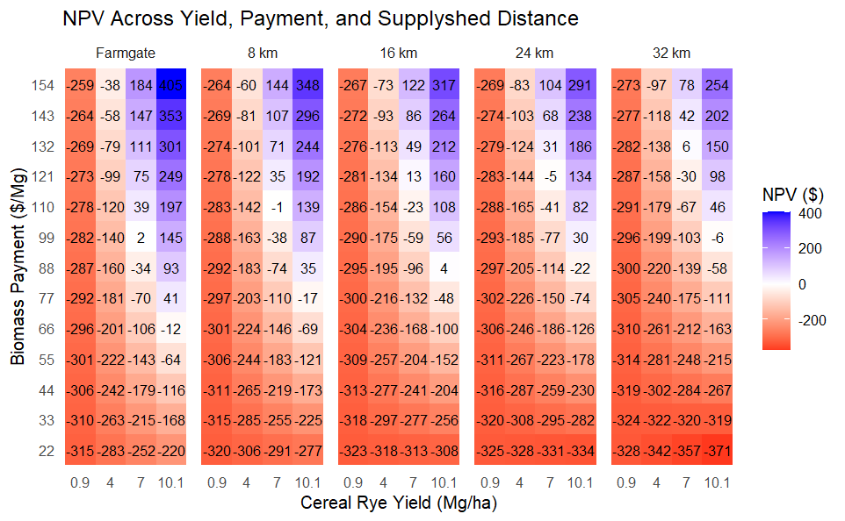
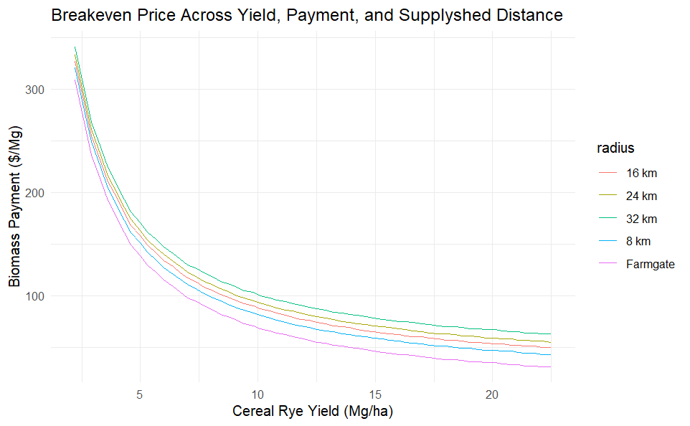
Table S13. Per hectare annualized net benefits of a bioenergy cereal rye biomass system selling to an anaerobic digester (AD) facility in Iowa, USA given yield and scenario dependent annualized production costs at a 6% discount rate. The farmgate scenario calculates net benefits of establishing, fertilizing, harvesting and selling cereal rye. The four radial supplyshed distances look at the net benefits of the AD system and includes trucking and loading/unloading costs. Prices are in 2026 USD.
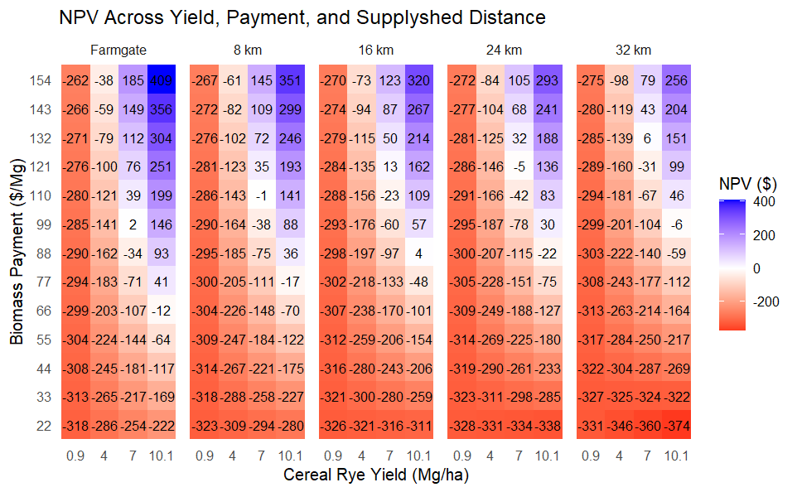


Table S14. Per hectare annualized net benefits of a bioenergy cereal rye biomass system selling to an anaerobic digester (AD) facility in Iowa, USA given yield and scenario dependent annualized production costs at a 7% discount rate. The farmgate scenario calculates net benefits of establishing, fertilizing, harvesting and selling cereal rye. The four radial supplyshed distances look at the net benefits of the AD system and includes trucking and loading/unloading costs. Prices are in 2026 USD.
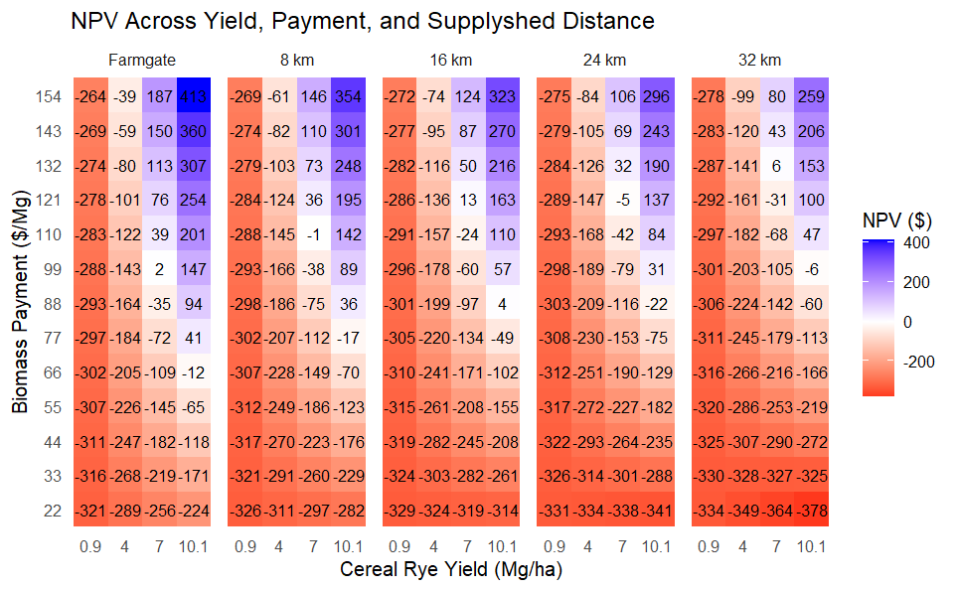


Table S15. Per hectare annualized net benefits of a bioenergy cereal rye biomass system selling to an anaerobic digester (AD) facility in Iowa, USA given yield and scenario dependent annualized production costs at an 8% discount rate. The farmgate scenario calculates net benefits of establishing, fertilizing, harvesting and selling cereal rye. The four radial supplyshed distances look at the net benefits of the AD system and includes trucking and loading/unloading costs. Prices are in 2026 USD.
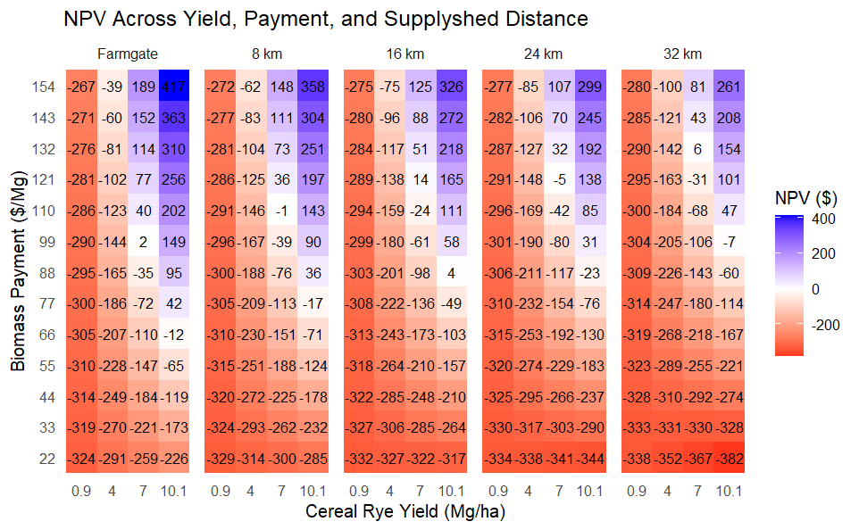

Table S16. Per hectare annualized net benefits of a bioenergy cereal rye biomass system selling to an anaerobic digester (AD) facility in Iowa, USA given yield and scenario dependent annualized production costs at a 9% discount rate. The farmgate scenario calculates net benefits of establishing, fertilizing, harvesting and selling cereal rye. The four radial supplyshed distances look at the net benefits of the AD system and includes trucking and loading/unloading costs. Prices are in 2026 USD.
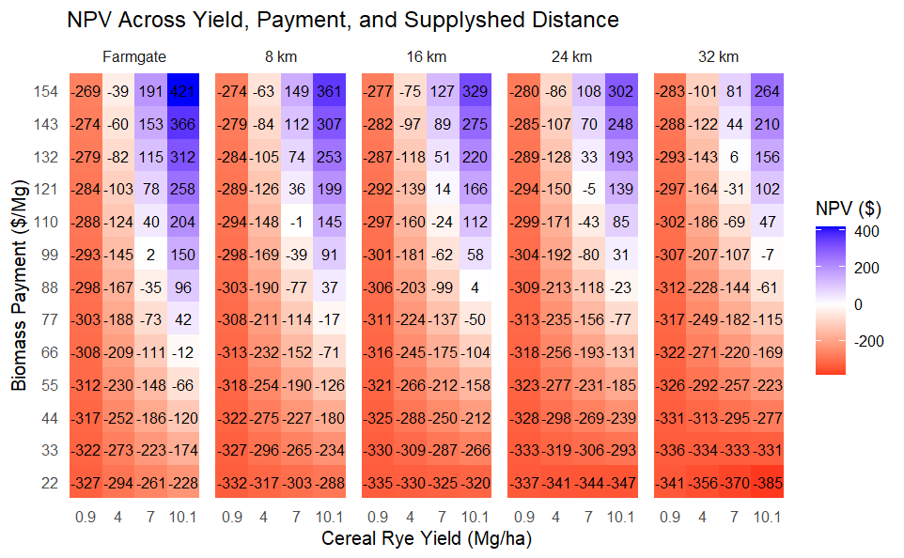

Table S17. Per hectare annualized net benefits of a bioenergy prairie biomass system selling to an anaerobic digester (AD) facility in Iowa, USA given yield and scenario dependent annualized production costs at a 5% discount rate. The top panel estimates net benefits when direct costs and opportunity costs are considered. The farmgate scenario calculates net benefits of establishing, fertilizing, harvesting and selling prairie. The four radial supplyshed distances look at the net benefits of the AD system and includes trucking and loading/unloading costs within each radial band. Prices are in 2026 USD.
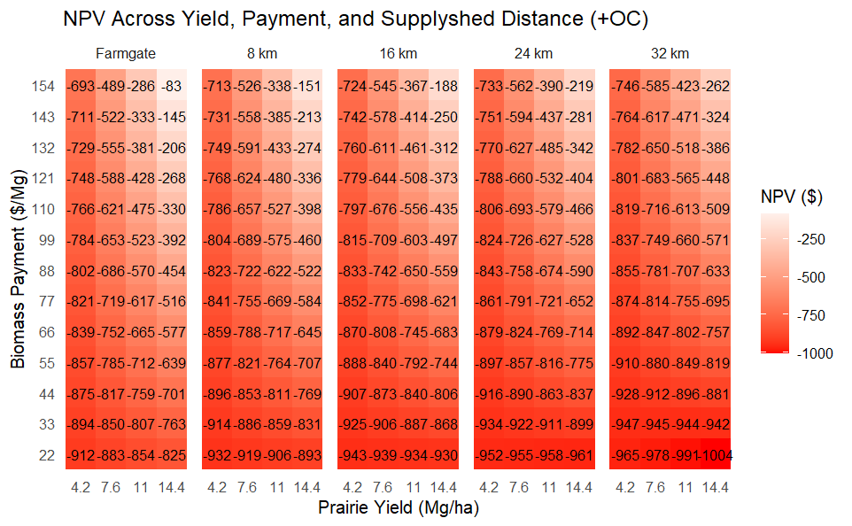
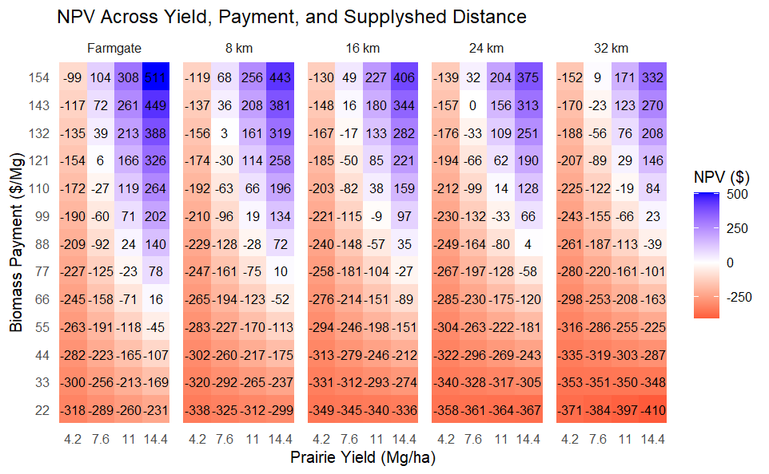
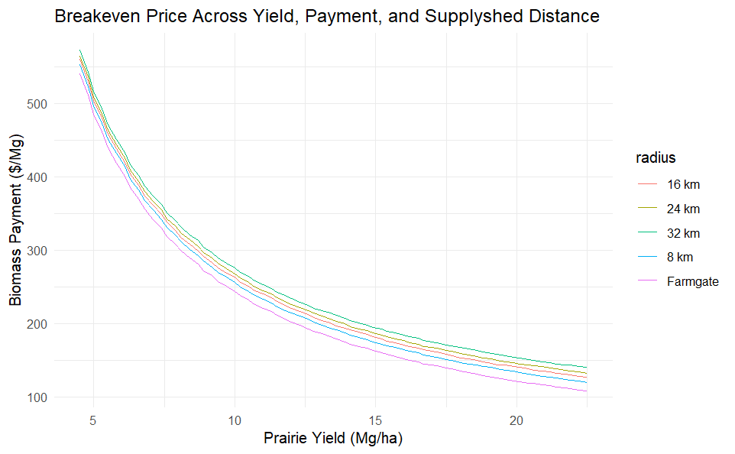
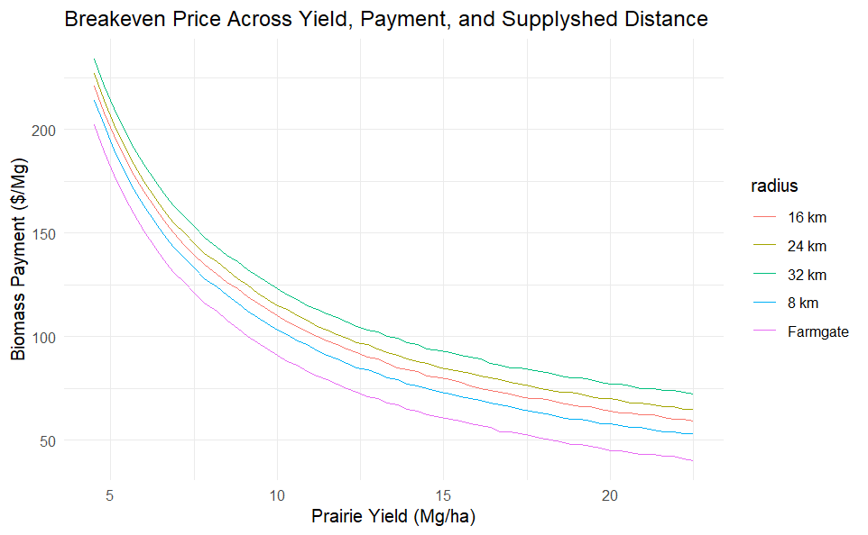
Table S18. Per hectare annualized net benefits of a bioenergy prairie biomass system selling to an anaerobic digester (AD) facility in Iowa, USA given yield and scenario dependent annualized production costs at a 6% discount rate. The top panel estimates net benefits when direct costs and opportunity costs are considered. The farmgate scenario calculates net benefits of establishing, fertilizing, harvesting and selling prairie. The four radial supplyshed distances look at the net benefits of the AD system and includes trucking and loading/unloading costs within each radial band. Prices are in 2026 USD.
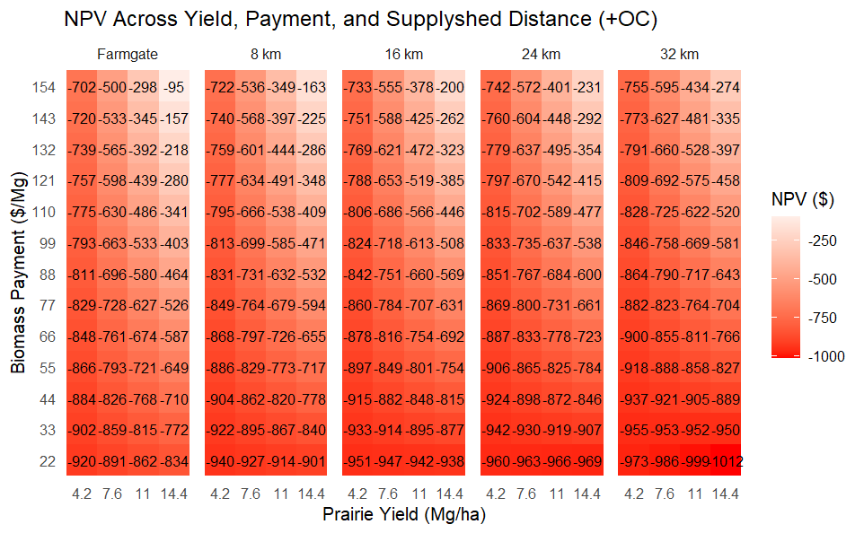
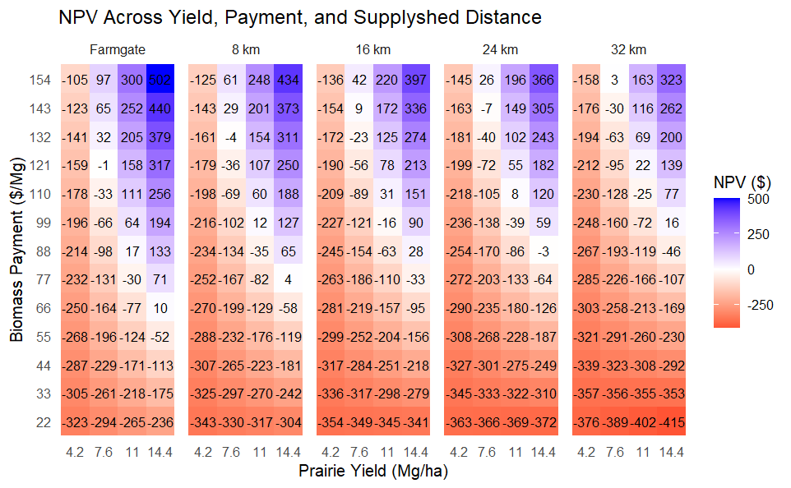

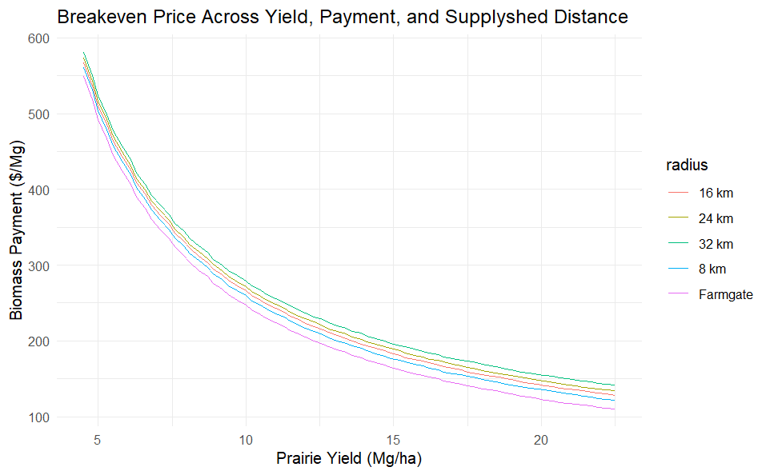
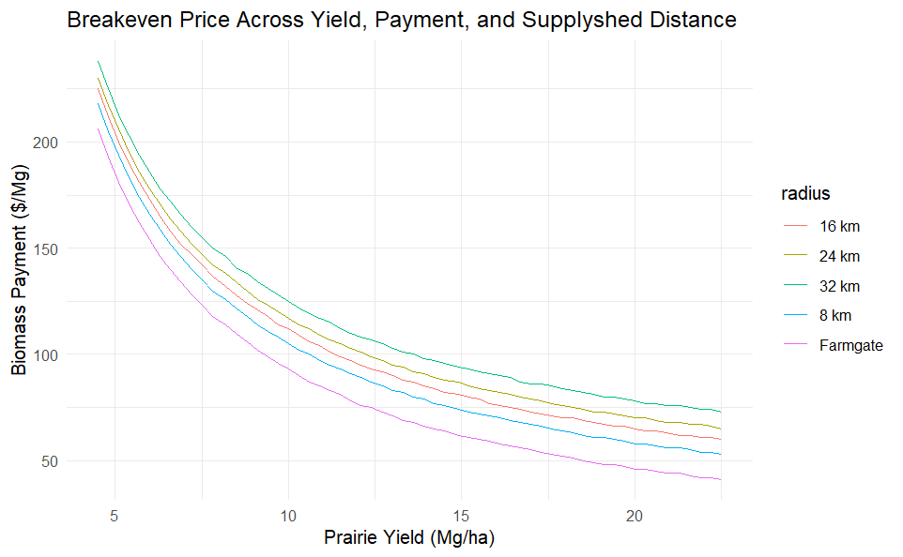
Table S19. Per hectare annualized net benefits of a bioenergy prairie biomass system selling to an anaerobic digester (AD) facility in Iowa, USA given yield and scenario dependent annualized production costs at a 7% discount rate. The top panel estimates net benefits when direct costs and opportunity costs are considered. The farmgate scenario calculates net benefits of establishing, fertilizing, harvesting and selling prairie. The four radial supplyshed distances look at the net benefits of the AD system and includes trucking and loading/unloading costs within each radial band. Prices are in 2026 USD.
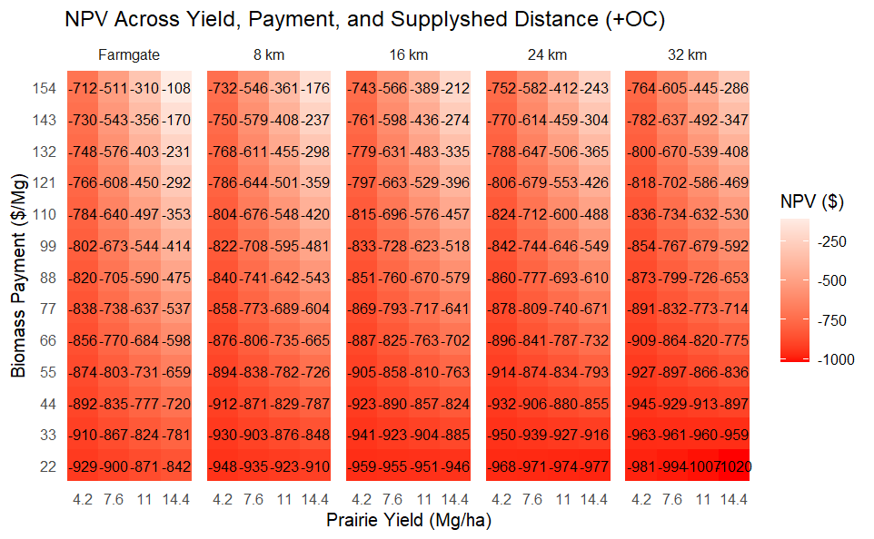
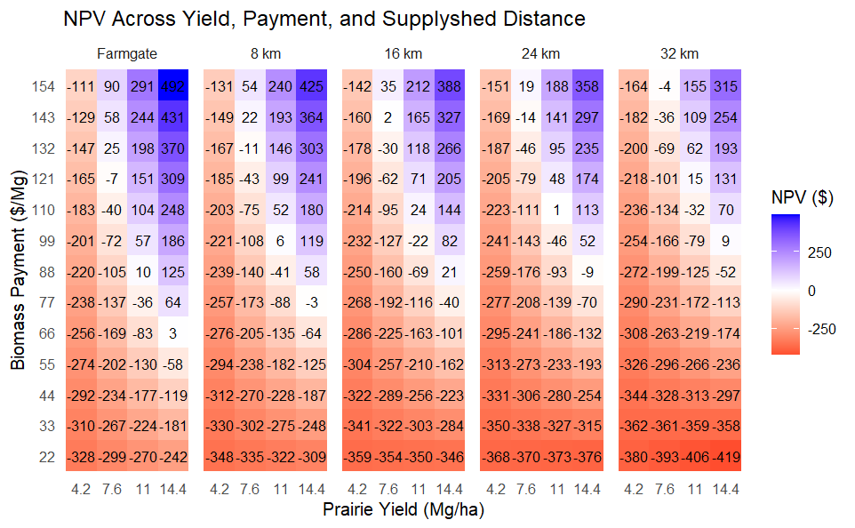
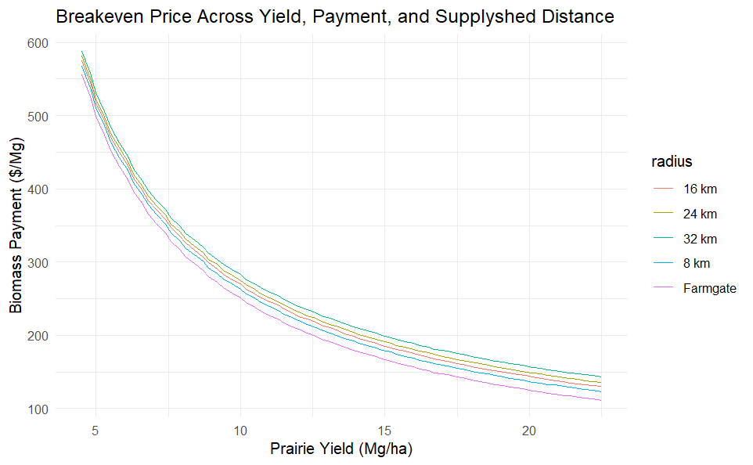
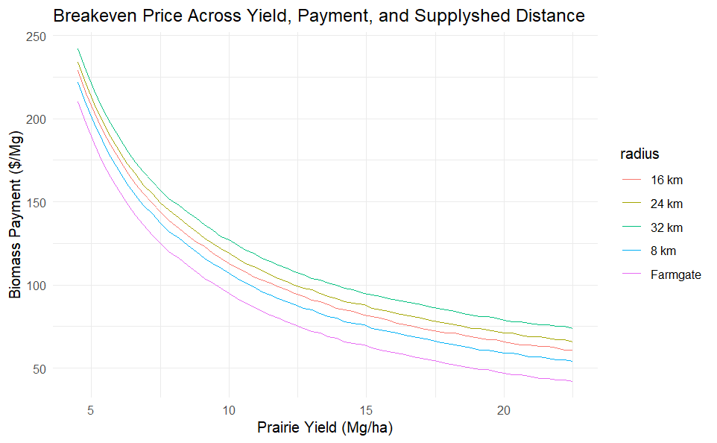

Table S20. Per hectare annualized net benefits of a bioenergy prairie biomass system selling to an anaerobic digester (AD) facility in Iowa, USA given yield and scenario dependent annualized production costs at a 8% discount rate. The top panel estimates net benefits when direct costs and opportunity costs are considered. The farmgate scenario calculates net benefits of establishing, fertilizing, harvesting and selling prairie. The four radial supplyshed distances look at the net benefits of the AD system and includes trucking and loading/unloading costs within each radial band. Prices are in 2026 USD.
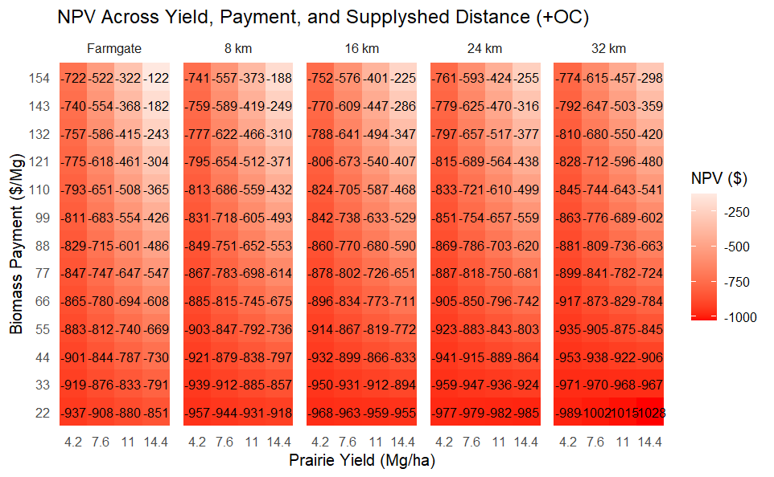
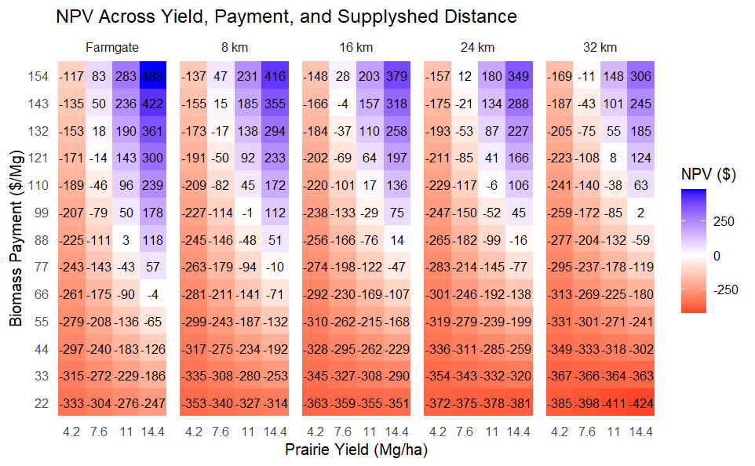
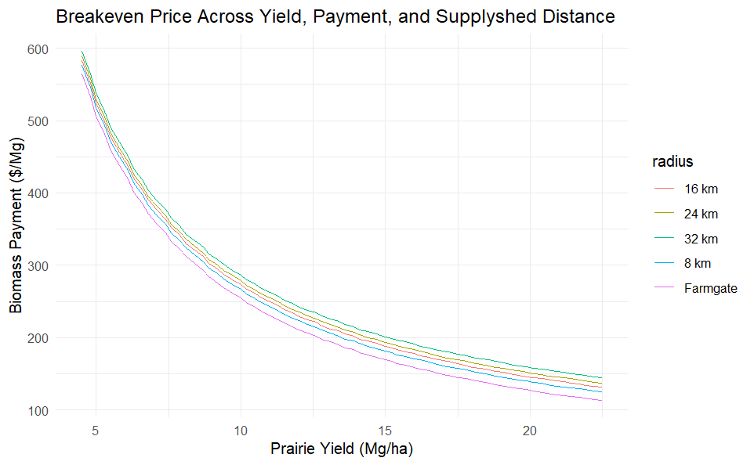
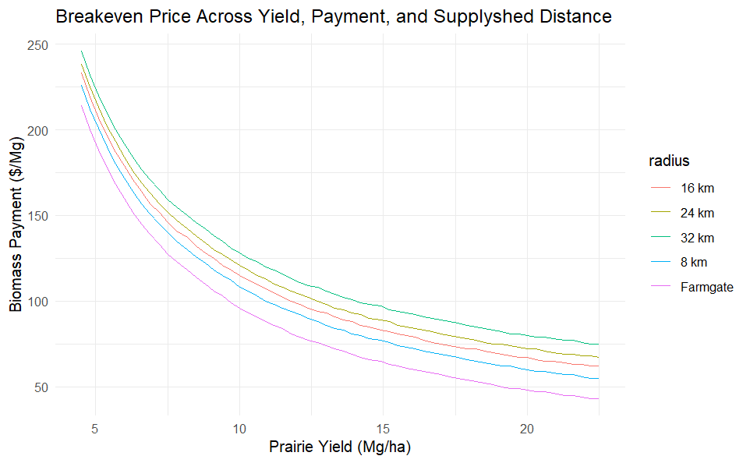
Table S21. Per hectare annualized net benefits of a bioenergy prairie biomass system selling to an anaerobic digester (AD) facility in Iowa, USA given yield and scenario dependent annualized production costs at a 9% discount rate. The top panel estimates net benefits when direct costs and opportunity costs are considered. The farmgate scenario calculates net benefits of establishing, fertilizing, harvesting and selling prairie. The four radial supplyshed distances look at the net benefits of the AD system and includes trucking and loading/unloading costs within each radial band. Prices are in 2026 USD.
